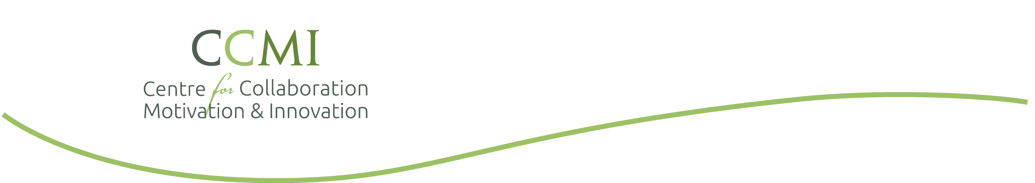

**Health Literacy Workshop Agenda**

Version Date: 29 October 2018

[Insert Location]

[Date]

|  |  |
| --- | --- |
| Time* | Activity |
| 8:30 | Welcome |
| 8:40 | Introduction to Health Literacy   * Describe experiences of a person with low health literacy. * Define health literacy. * State prevalence of low health literacy. * Describe components of health literacy. |
| 9:00 | The Overall Approach to Health Literacy: Universal Precautions   * Describe factors that contribute to low health literacy. * State reasons for Universal Precautions in Health Literacy. * Describe ways to create a shame-free environment. * Describe the key learner. |
| 10:00 | BREAK |
| 10:15 | Health Literacy Skills   * Use plain language principles for written and oral communication. * Describe a simple approach to usability testing. * Demonstrate effective methods to use printed materials in practice |
| 12:00 | LUNCH |
| 12:30  (note: two 10 minute breaks will occur during the afternoon) | Health Literacy Skills (cont.)   * Define teach-back. * Describe the evidence for using teach-back. * Demonstrate teach-back * Demonstrate ask-tell-ask * Describe tips for using an interpreter. * Describe contribution of understanding to medication adherence. |
| 3:30 | Health Literacy strategies   * Describe assessment of a health literate organization |
| 4:00 | Health Literacy in the community   * Consider approaches to address health literacy across a community |
| 4:15 | Next steps, closing, feedback |
| 4:30 | Adjourn |

* Times and topics (except for breaks) subject to change based on needs of the group

Videos

Bobby McFerrin demonstrates the pentatonic scale

<http://www.youtube.com/watch?v=ne6tB2KiZuk>

American Medical Association: Help Your Patients Understand

<http://www.youtube.com/watch?v=cGtTZ_vxjyA>

What is self-managing?

<https://youtu.be/uRQ853sRt0o>

This is Bad Enough

<https://www.youtube.com/watch?v=R3tJ-MXqPmk>

Who is Mark Twain?

<http://www.youtube.com/watch?v=JpKBEWo-UrI>

The Power of Words

<https://www.youtube.com/watch?v=QYcXTlGLUgE>

Teach-back Example

<https://youtu.be/d702HIZfVWs>

Dee Westry, Speed Painter

<https://www.youtube.com/watch?v=k8AkjWQ3P-M>

Ask-Tell-Ask examples:

<https://vimeo.com/85555368>

<https://youtu.be/Bwq0qAFRct8>

<https://youtu.be/77-hRQETxzU>

Example of a video for the public from the Kelty Centre

<https://www.youtube.com/watch?v=iO5QynPcuPk>

Playing for Change: What a Wonderful World

<https://youtu.be/ddLd0QRf7Vg>

